D. Y. Patil College of College of Engineering and Technology, Kolhapur
Department of Computer Science & Engineering

Class: Final Year B. Tech. Div.: B
Subject: Non Structured Database

Experiment no: 10
Group No. 16 Mini Project

Title of Mini-Project: TalentGraph- Smart Recruitment and Talent Intelligence Platform Using
MERN and MongoDB

Problem Statement: Traditional recruitment systems often face challenges in managing candidate
information, searching for suitable candidates, tracking job applications, and
analysing recruitment performance. Manual screening of resumes and
matching candidates with job requirements can be time-consuming and
inefficient.
The objective of TalentGraph is to develop a smart recruitment platform using
MERN stack and MongoDB that enables recruiters to manage job postings,
discover suitable candidates, rank candidates based on skills and experience
and track recruitment activities. The system uses MongoDB's flexible
document model, indexing, and aggregation capabilities to improve candidate
search and recruitment analytics.
Introduction :
TalentGraph is a web-based recruitment and talent intelligence platform designed to connect
candidates with recruiters and job opportunities. The system provides separate interfaces for
candidates, recruiters, and administrators.
Candidates can create professional profiles, add skills and experience, search for jobs, apply
for suitable positions, and track their application status. Recruiters can publish job openings,
search candidate profiles, evaluate candidate-job compatibility, manage applications, and
schedule interviews. Administrators can manage users and monitor platform activities.

The project uses MongoDB as its primary database to store flexible candidate profiles, job details, applications, and recruitment records. MongoDB's indexing and aggregation features support efficient searching, candidate ranking, and generation of recruitment reports.

System Architecture: 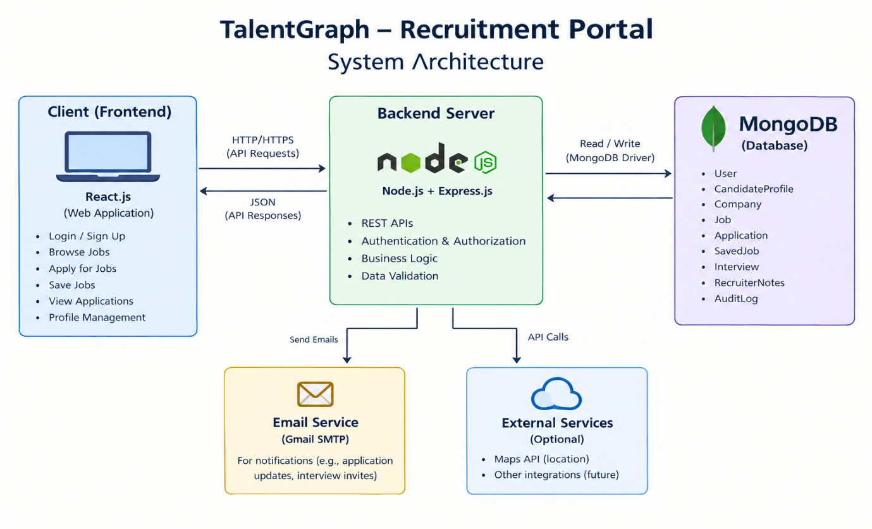
TalentGraph follows a three-tier architecture using the MERN stack.

Presentation Layer-
React.js · HTML · CSS · JavaScript · Tailwind CSS
Candidate, Recruiter and Admin Dashboards

Application Layer-
Node.js · Express.js · REST APIs
Authentication · Authorization · Matching Engine · Business Logic

Database Layer-
MongoDB · Mongoose

Working: The React frontend sends requests to the Express.js backend through REST APIs. The backend validates requests, applies business rules, and communicates with MongoDB through Mongoose. MongoDB stores and retrieves the data, and the backend returns the results to the frontend for display.

Module description or working of system:

- Authentication and User Management: Provides registration, login, and role-based access for
candidates, recruiters, and administrators.
- Candidate Profile Management: Allows candidates to maintain their professional information,
including skills, education, experience, projects, and resume details.
- Job Management: Enables recruiters to create, edit, publish, and close job postings containing job
descriptions, required skills, experience, salary, and location.
- Candidate Search and Matching: Allows recruiters to filter candidates by skills, experience, and location. A matching algorithm calculates a compatibility score between candidates and job requirements and explains matched and missing skills.
- Application Management: Allows candidates to apply for jobs and track their application status.
- Recruiters can review applications and move candidates through screening, shortlisting, interviews, offers, and hiring.
- Interview Management: Enables recruiters to schedule interviews, record meeting details, and
update interview status.
8. Recruitment Analytics: Displays statistics such as job postings, application counts, recruitment funnel stages, and hiring performance using database aggregation queries.
9. Administration: Allows administrators to manage users, moderate job postings, and monitor important platform activities.

Detail description of Nonstructured database used in miniproject:

MongoDB is a NoSQL, document-oriented database used as the primary database in TalentGraph.
Unlike relational databases that store information in tables and rows, MongoDB stores information
as BSON documents organized into collections.
Important MongoDB Features Used

- Flexible schema: Supports candidate profiles with different skills, projects, and work histories.
- Document model: Stores related information using embedded documents and arrays.
- Indexing: Creates indexes on frequently searched fields to improve query performance.
- Compound indexes: Supports queries that combine multiple filters, such as job status and location.
- Aggregation pipeline: Calculates application statistics, hiring trends, and recruitment funnel metrics using stages such as $match, $group, $sort, and $lookup.
- Text search: Supports keyword-based discovery of candidates and jobs using an appropriate text-search implementation.
- Unique constraints: Prevents duplicate applications for the same job by the same candidate through a unique compound index.
- References: Connects related collections using ObjectId references, such as linking applications to jobs and candidates.

Advantages of MongoDB in TalentGraph
- Handles flexible and evolving candidate profile structures.
- Supports nested documents and arrays.
- Provides efficient searches through suitable indexes.
- Enables database-driven recruitment analytics.
- Supports relationships between different collections using references.
- Provides schema validation and unique constraints to maintain data quality.

MongoDB is suitable for TalentGraph because candidate profiles contain flexible information such
as skills, work experience, education, and projects. These fields can vary between candidates,
making a document-oriented database useful.

- Collections Used:
- Users: Stores account information, login credentials, and user roles.
- Candidate Profile: Stores skills, education, experience, projects, and preferences.
- Companies: Stores company information and recruiter ownership.
- Jobs: Stores job descriptions, requirements, salary ranges, and status.
- Applications: Stores applications, match scores, and recruitment status history.
- Saved Jobs: Stores jobs bookmarked by candidates.
- Interviews: Stores interview schedules and meeting details.
- Recruiter Notes: Stores internal recruiter feedback on applications.

2. Document Structure
A candidate profile can contain nested documents and arrays within a single MongoDB document.

Example:
{
"headline": "MERN Stack Developer",
"experienceYears": 2,
"skills": [
{
"name": "React",
"proficiency": "Advanced"
},
{
"name": "MongoDB",
"proficiency": "Intermediate"
}
],
"education": [
{
"degree": "B.Tech",
"field": "Computer Science"
}
],
"preferredLocations": ["Pune", "Bengaluru"]
}

Example: {
_id: ObjectId('6ae2d2bc78fd80d8a433b4eb'),
jobId: ObjectId('6ae2d28878fd80d8a433b4d7'),
candidateId: ObjectId('6ae2d0fa78fd80d8a433b4b0'),
profileSnapshot: Object(4),
status: "applied",
matchScore: 86,
statusHistory: Array(1),
createdAt: ISODate('2026-10-29T04:59:40.766+00:00'),
updatedAt: ISODate('2026-10-29T04:59:40.766+00:00'),
__v: 0
}
This structure allows related candidate information to be stored together while supporting flexible fields and nested data.
3.Indexing and Query Optimization
TalentGraph uses indexes on frequently queried fields, including candidate skills, job status, location, and application references. Compound indexes are selected according to actual query patterns.
MongoDB's explain("executionStats") can be used to inspect query execution, document examination, and index usage. This helps demonstrate the impact of database optimization.

4. Aggregation in Recruitment Analytics
The aggregation pipeline processes stored records to generate useful statistics. For example, applications can be grouped by status to calculate the number of candidates in screening, interview, offer, and hired stages.
The $lookup stage can combine related information from different collections, while $group calculates totals and $sort orders results.

Screenshots:

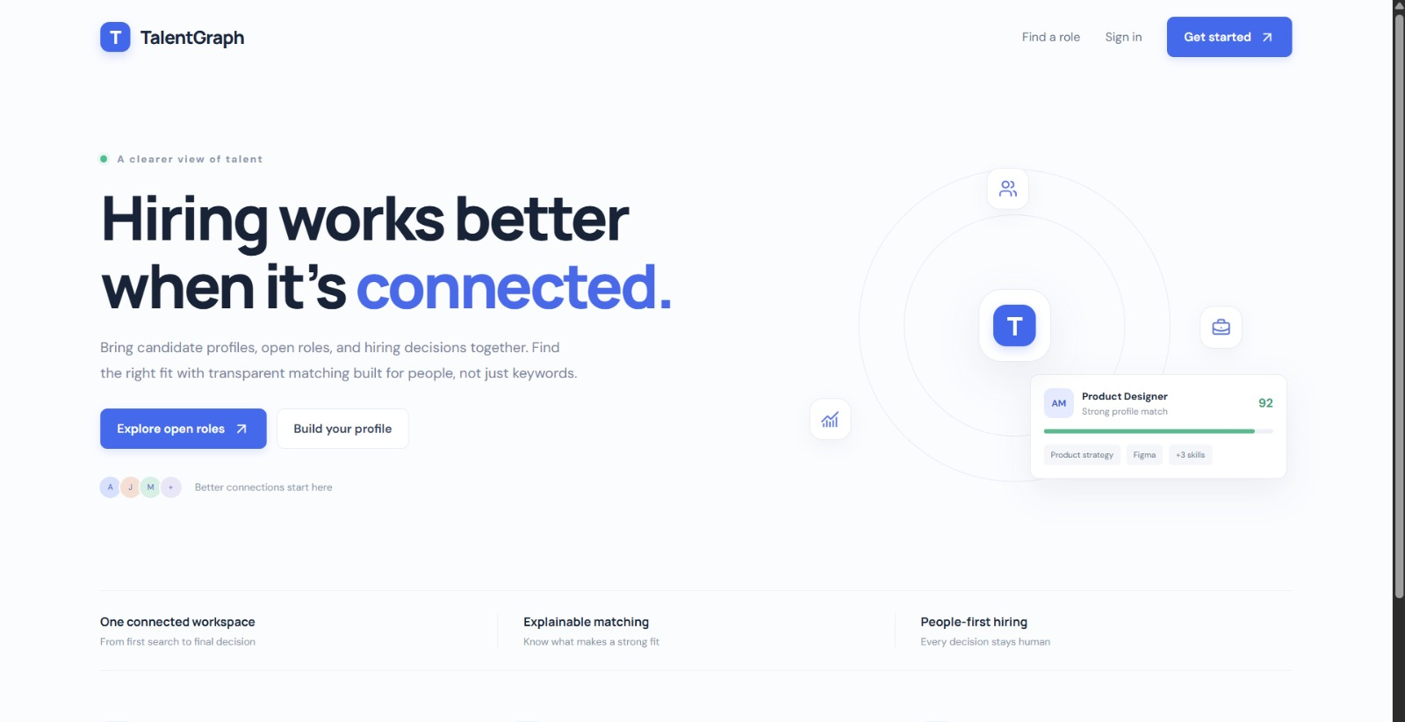

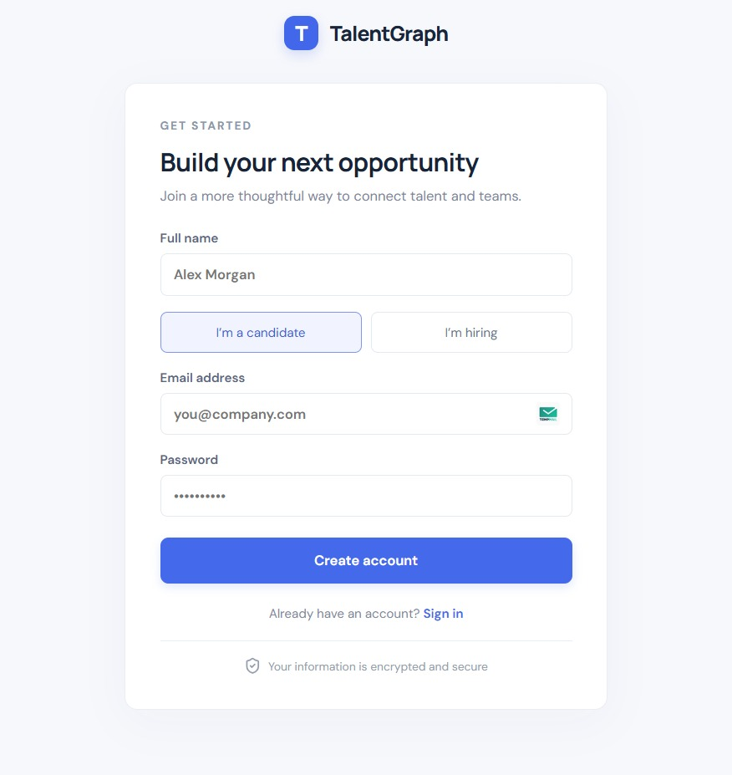

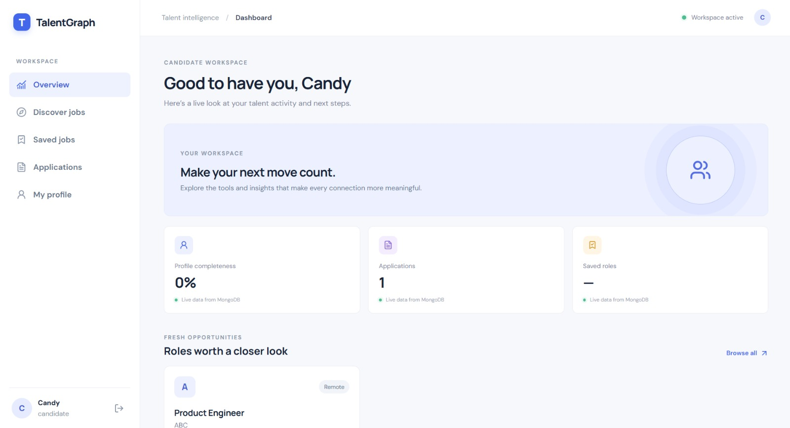

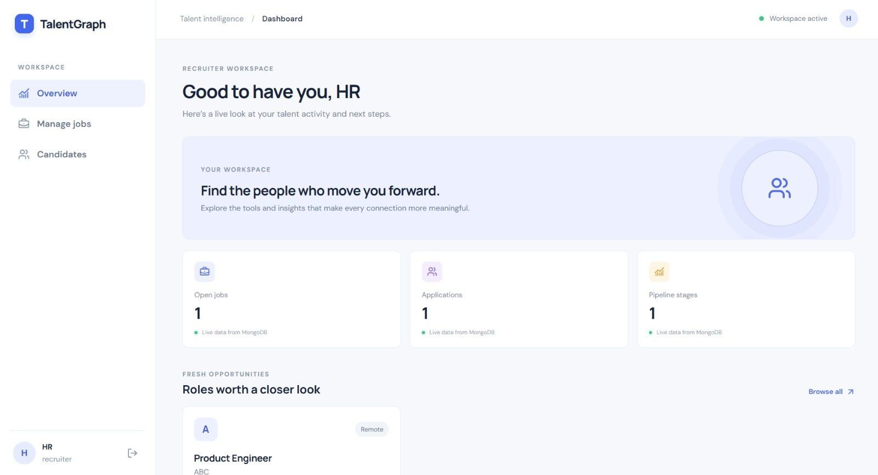

Conclusion :
MongoDB is the core database component of TalentGraph. Its document-oriented storage, indexing, and aggregation capabilities support flexible candidate management, intelligent job matching, application tracking, and recruitment analytics within a scalable MERN-stack application.

Group Members:
Unique id | Roll No | Name of Student | Sign
EN23187816 | 6 | Revatee Ranjit Ghatage
EN23221773 | 7 | Ankita Ankush Ghunake
EN23264023 | 8 | Vaishnavi Kashinath Gavade
EN23164031 | 9 | Sanaa Khushahmad Shaikh
EN23230183 | 10 | Swapnali Rajaram Mane

